**Daelink: Job opportunity for people with special needs**

*Daelink: Vaga de Emprego para pessoas com necessidades especiais*

*Daelink: Oportunidad laboral para personas con necesidades especiales*

|  |  |
| --- | --- |
| **Keywords:**  *Inclusion.*  *PWN.*  *Labor Market.*  *Digital Platforms.*  **Palavras-chave:**  *PCD.*  *Mercado de Trabalho.*  *Plataforma Digital.*  *Inclusão.*  **Palabras clave:**  inclusión*.*  PCD*.*  mercado laboral*.*  plataformas digitales*.*  **Presented on:**  December,05th,2024  **Event:**  7º EnGeTec  **Event local:**  Fatec Zona Leste  **Evaluators:**  Avaliador 1  Avaliador 2  [Desenho com traços pretos em fundo branco e letras pretas em fundo branco  Descrição gerada automaticamente com confiança média](https://creativecommons.org/licenses/by-nc-sa/4.0/) | **Abstract:**  This work aims to deal with the inclusion of people with special needs (PWDs) in the labor sector through a system based on digital platforms that promote connectivity. Quotas for them are often not filled due to a lack of demand from companies and prejudice. Although there are actions to establish quotas for People with special needs, inclusion faces significant challenges, resulting in lower participation rates in the labor market compared to people without special needs; in this way, the project consists of the study of developing a digital platform that promotes professional inclusion to facilitate the integration of PWN into the job market. The theoretical support used to include the analysis of the needs of PWN and companies. Results indicate that a prototype system, consisting of a website and an application, can be created that companies can use to fill the remaining vacancies within their institutions. Its construction is designed for companies that highlight the leading candidates for remaining vacancies in certain areas. Therefore, the project can be qualified to enhance the inclusion of PWN in the Labor Market.  **Resumo:**  Este trabalho tem como objetivo tratar sobre a inserção de pessoas com deficiência (PCDs) ao setor trabalhista através de um sistema baseado em plataformas digitais que promovem conectividade. As cotas para PCDs frequentemente não são preenchidas corretamente, devido à falta de busca das empresas junto de fatores preconceituosos. Embora existam ações que estabeleçam cotas, a inclusão dessas pessoas se depara com desafios significativos, gerando menores taxas de participação no campo de trabalho, ao se comparar com pessoas sem deficiência. Desta maneira o projeto consiste no estudo de desenvolver, e facilitar a inclusão profissional destas pessoas. A metodologia empregada inclui a análise das necessidades de PCDs e empresas, e através dela moldando o projeto para se adequar a elas. Os resultados indicam a criação de um protótipo, composto por site, e aplicativo que pode ser utilizado pelas empresas para preencher estas vagas de forma facilitada. A sua construção é pensada essencialmente para empresas, consistindo em um site e aplicativo que mostram os principais candidatos para vagas remanescentes de determinadas áreas. Portanto, demonstra-se que a plataforma pode ampliar o preenchimento de vagas.  **Resumen:**  El objetivo de este trabajo es abordar la integración de las personas con discapacidad (PCD) en el sector laboral. Los cupons para personas con discapacidad a menudo no se cubren correctamente, debido a la falta de búsqueda por parte de las empresas y a factores prejuiciosos. Si bien existen acciones que establecen cupons, la inclusion de estas personas enfrenta importantes desafíos con las personas sin discapacidad. Por ello, el proyecto consiste en estudiar cómo desarrollar y facilitar la inclusíon profesional de estas personas. La metodología empleada incluye el análisis de las necesidades de las personas con discapacidad y de las empresas, para después configurar el proyecto a su medida. Los resultados indican la creación de un prototipo, consistente en una página web y una aplicación que pueden utilizar las empresas para cubrir estas vacantes de forma más sencilla. Su construcción está pensada esencialmente para las empresas, y consiste en una página web y una aplicación que miestran los principales candidatos para las vacantes que quedan en determinadas áreas. Por lo tanto, la plataforma puede utilizarse para ayudar a cubrir vacantes. |

# Introduction

Integrating individuals with special needs (PWN) into the labor market through digital connectivity platforms represents a significant and pressing concern. Despite numerous social initiatives aimed at integrating PWNs into society, the number of PWNs employed in companies remains disproportionately low, as evidenced by the insufficient fulfillment of established quotas. This persistent exclusion of PWNs from the labor market underscores the continuous need for more robust measures to facilitate their inclusion. (INTERNATIONAL DISABILITY ALLIANCE, 2022). Therefore, this study aims to develop a system that promotes connectivity more efficiently through a website and a mobile application to enhance the integration between companies and their PWNs. In this context, the labor market participation and formalization rates of people with special needs aged 14 and over are significantly lower than those of people without special needs. The labor market participation rate of people with special needs is 23.8%, while the formalization rate is 34.3%. The rates for people without special needs are 66.3% and 50.9%, respectively (IBGE, 2022). One of the primary constraints impeding the inclusion of PWNs in the labor market is prejudice. Many companies remain reluctant to hire individuals with special needs, often due to a lack of awareness about these professionals' skills and abilities. (CNN, 2021).

It is, therefore, imperative to identify solutions that facilitate the integration between companies and PWN, thereby increasing opportunities and hiring these professionals through modern technology to promote a more inclusive society. In light of these considerations, it becomes pertinent to inquire why the quotas for PWNs in the labor market remain unfulfilled and demonstrate how a digital platform for professionals can facilitate the integration of these individuals into companies. The hypothesis is that using a digital system specifically designed to connect companies and people with special needs can increase the filling rate in the labor market, facilitating the recruitment process and overcoming current barriers, such as prejudice. This study aims to develop a digital platform that enables the integration of people with special needs into the labor market, promoting a more inclusive work environment and increasing the number of quota positions.

The initial stage involved a bibliographic review of the inclusion of PWNs in the labor market, emphasizing inclusion studies and tools to ascertain how digital platforms can facilitate the hiring of PWNs. Based on the findings of this review, the quantitative method and study case to gather all data and analyze specific problems, employing both inductive and deductive methods by the approach set forth by Lakatos and Marconi (2017) along with PEREIRA et al. (2018) and GIL (2002). The research will address several seminal authors in the field, including CNN (2022), which analyzes the importance of using technology to enhance inclusion. The authors will be referenced throughout the article to provide theoretical support for developing the platform and its potential solutions for the inclusion challenge. The development was divided into three sections: the web, a mobile application, and the recommendation system. React Vite was selected for web development due to its straightforward component creation and processing capabilities (SCHMITZ; GEORGII, 2015). React Native was employed for mobile app development due to its native and cross-platform compatibility with Android and iOS (ESCUDELARIO; PINHO, 2020). The recommendation system utilized Python for its extensive toolset, including Scikit-Learn for machine learning (MENEZES, 2014).

# Theoretical Foundation

This chapter abstracts all the stages of the theoretical foundation for understanding this article and presents concepts and technologies. It aims to demonstrate all the theoretical underpinnings of the DAELink platform.

## Challenges of Inclusion in the Labor market for people with special needs

In Brazil, around 18.6 million people in Brazil between two and more have some type of disability, and inclusion is a challenge that persists in Brazil due to the lack of accessibility and adequate support (G1, 2023).

Highlighted by a comparatively inadequate perspective about other candidates, along with challenges rooted in internalized societal prejudices that hinder adaptive processes in new circumstances, both in general and corporate environments (RIBEIRO; DELLATORRE, 2021).

According to data from the Brazilian Institute of Geography and Statistics (IBGE, 2022), individuals with special needs face more significant difficulties entering the labor market. The labor force participation rate for people with special needs is about 28.3%, compared to 66.3% for those without special needs, as shown in Figure 1.

Figure 1 – Estudo IBGE

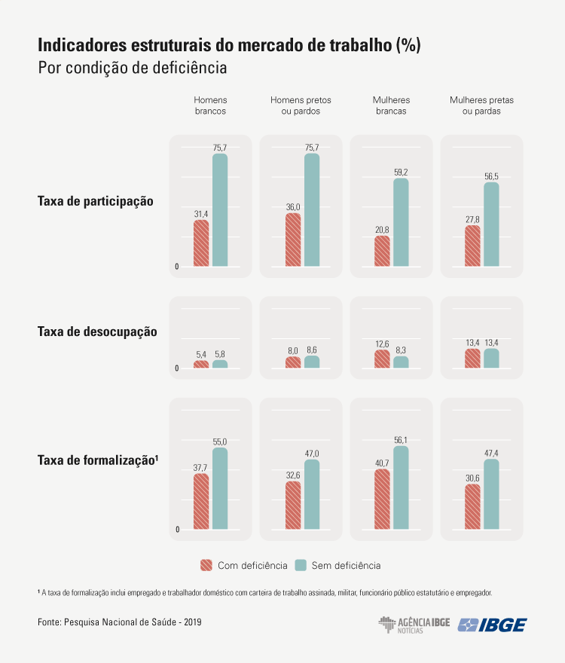

Source: IBGE (2022)

Unemployment among people with special needs is higher when compared to people without special needs, and this inequality ends up affecting young people (CNN, 2022). These people end up receiving lower incomes, about two-thirds of the value of people without special needs, with a higher incidence of extreme poverty, especially in sectors such as agricultural and domestic services.

## Legislation and solutions for businesses and people with special needs

Brazil establishes that companies with one hundred employees or more are required to fill 2% to 5% with people with special needs, known as law quotas, according to Article 1 of Law No 8,213 of July 24, 1991:

Article 1: Social Security, using contributions, aims to ensure its beneficiary's indispensable means of maintenance due to incapacity, involuntary unemployment, advanced age, length of service, family burdens, and imprisonment or death of those on whom they depended economically. (BRAZIL,1991, OUR TRANSLATE)

Although the law has been in effect for around thirty years, it cannot be said to have been fully enforced due to legislative issues, such as the need for better specifications, and other challenges, like the lack of professional qualifications for people with special needs (SANTOS NETO, 2020).

In the contemporary, an increasing number of companies are recognizing the substantial advantages associated with including disabled workers who are fully engaged, possess remarkable talent, and demonstrate outstanding work ethic. Consequently, organizations are implementing proactive measures to actively recruit and hire individuals with special needs to reduce turnover and enhance revenue and profitability (WINIARSKI, 2024). This is due to the lack of an accessible system, which generates a gap in the connection between People with special needs. Therefore, there is a need to create a system for this digital integration. The solution for a digital connectivity platform can promote social inclusion and improve these people.

## DaeLink system for companies to fill their vacancies for people with special needs

The project focuses on creating a system for web and mobile applications based on JavaScript languages and with a cloud database that allows business users to connect in a simplified way and thus fill their vacancies through a recommendation system, chat, and the availability of vacancies. The tools described below were used to achieve this.

Figure 2 – Process page website

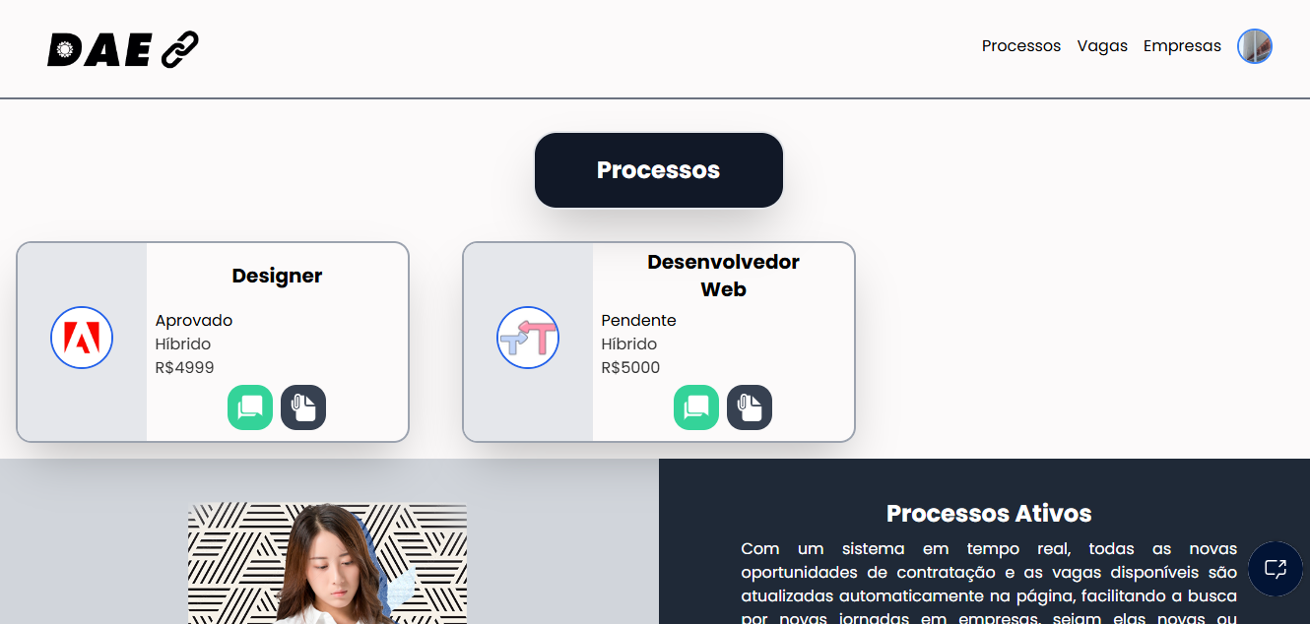

Fonte: self-authored (2024)

## React Vite

React is a JavaScript library for creating partitioned interfaces that can be combined into components, such as websites and mobile applications (REACT).

Jordan Walke, an engineer at Facebook, created it in 2011 to simplify and speed up interface creation. It has become the most popular JavaScript library (SILVA, 2021).

Vite comes from the French meaning "fast," as demonstrated in its proposal to be a tool that allows the creation of front-end projects in an accessible way. It is light and practical, bringing creative concepts to web pages (VITE).

## React Native

React Native is a platform-based tool on React that enables the creation of hybrid applications running on iOS (Apple) and Android. It was created by Facebook in 2013. React Native can be defined as an open-source framework that aims to develop native applications; that is, there is a web layer as an interface, but the native application itself (CASA GRANDE; TANAKA, 2023).

## Expo

Expo, along with React’s create-react-app package, provides the necessary structure to develop an application, offering an environment that simplifies the creation of mobile applications (ESCUDELARIO; PINHO, 2020). Expo is a tool used in mobile development with React Native that allows easy access to some native APIs without needing to install additional dependencies or modify native code (ROCKETSEAT, 2020). This makes the development process faster and more accessible for developers.

## Python

Python is a highly efficient programming language because programs constrain Dewar lines of code, helping to build “clean” code, obtaining a quick understanding, and debugging (MATTHERS, 2016).

Python often requires additional packages that are not included in the Anaconda distribution. One such package manager is pip, a tool that manages and installs Python packages (MCKINNEY, 2018). In this sense, two types, Conda and Pip, serve different purposes. Conda provides general package management for various languages in the Conda environment, and Pip offers services specifically for Python (MUELLER, 2020).

## Machine Learning

Machine Learning uses data filtering to create current information, generate noteworthy results, and enable intelligent decision-making through the data generated (KNEUSEL, 2024). Technology constantly evolves, and machine learning has become crucial for advancing various commercial areas, which has been adopted by today´s most prominent companies, such as Netflix (DOMINGOS, 2017).

## Firebase

Firebase Database is an effective tool for database creation, working through a real-time data update, and cloud-based storage. These features allow multi-platform projects to perform efficiently while offering compatibility with other Google Systems (FIREBASE).

## UML

The Unified Modeling Language is a visual representation that helps to understand the system in its logical part. It is an accepted international standard for software (GUEDES, 2018).

Used to carry out a complete project, it needs to be able to be changed later and allow a better understanding between customers and developers (PEREIRA, 2011). In general terms, the diagrams that make up the UML approach the entire project in different technical ways to obtain a better result in its completion (GUEDES, 2018).

# Methodology

For the construction of the project, multiple methodologies were used for a better elaboration of the work, analyzing fundamental points that concern the compliance of people with special needs in the job market and the practical part of companies in this integration. Since these aspects are highlighted by Gil (2002), a solid structure based on bibliographic surveys and quantitative research reworked by the case study provides an adequate perspective on a given subject.

The Quantitative study is a method used to analyze a problem with data and statistics. We are following the relevance of quantitative data to understand the distribution of opportunities (PEREIRA et al., 2018). By employing this method, we seek to analyze patterns, identify statics, and the impact of including people with special needs in the job market.

The case study is a methodological process directly related to an in-depth analysis of the specific phenomenon, examining its multiple dimensions and associated factors to identify the root causes of a given problem (GIL, 2017). This type of study is essential for clarifying typical issues in research and practice. It investigates the discrepancy in the job market experienced by people with special needs, helping identify the principles contributing to this inequality (GIL, 2002).

Finally, a bibliography study provides an investigative and theoretical analysis of a given content using articles and bibliographic sources (GIL, 2017). This methodology analyzes the perspective of researchers in the field to elucidate the members of the job market and their interconnection with individuals with special needs.

## Technology Use

The technologies mentioned in the preceding chapter are utilized for formatting and developing the project. Each tool is essential due to its efficacy in constructing the system. React has been used as a library to create the user interface and integrate with the Firebase database.

In this way, the home interface will be presented where the user will be able to view project information, represented in Figure 3

Figure 3 – Home Page DaeLink website

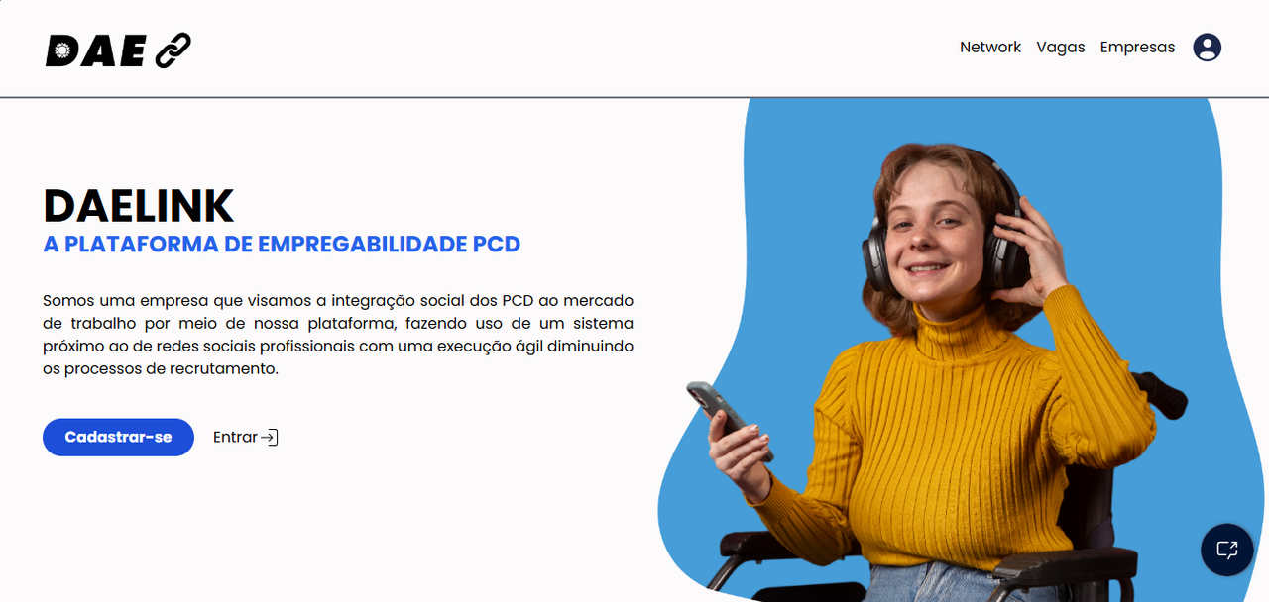

Source: self-authored (2024)

Python was employed with machine learning to develop the DaeLink recommendation system. The system enables companies to efficiently and automatically identify individuals with special needs registered on the platform.

Figure 4 shows the recommendation system with an example of a "Sales" vacancy and the terminal that demonstrates the similarity between the vacancies.

Figure 4 – Screen and terminal on system recommendation 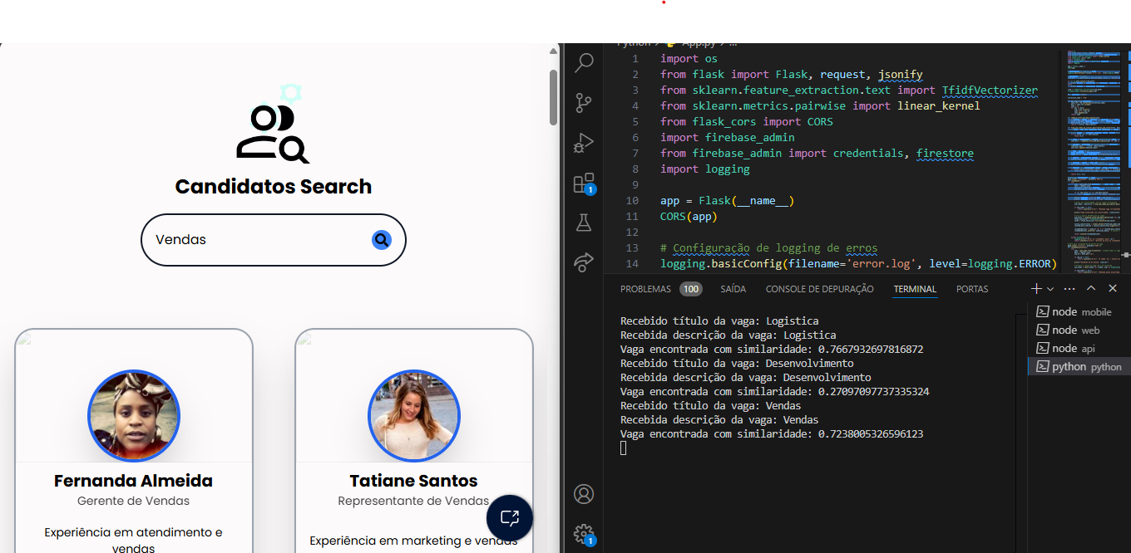

Fonte: self-authored (2024)

In mobile development, we utilize React Native in conjunction with Expo and Firebase, enabling the application to provide web and mobile platforms access. The mobile application has been designed for people with special needs. It allows them to view and manage the vacancies for which they have applied.

Figure 5, shows the application's home screen, along with its main functionalities and navigability, which gives a better perception of the view that a person with special needs can access.

Figure 5 – Home page mobile

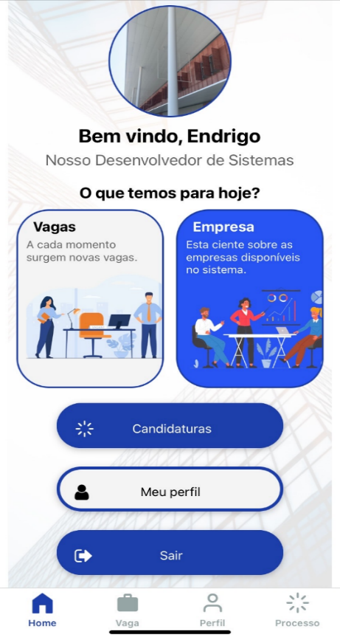

Fonte: self-authored (2024)

Using the Unified Modelling Language (UML) was relevant to the system's planning, providing its construction through use cases, sequences, activities, and state machines. The diagrams were of significant value in facilitating the organization and execution of the project in a clear and structured manner.

In addition to the technologies, the project methodology was based on the approach proposed by Lakatos and Marconi (2017), Gil (2002), and Pereira et al. (2018). The method provides a systematic approach to defining objectives, problem statements, and procedures. This approach facilitated the organization of the DaeLink development process, integrating quantitative and qualitative analysis to address the challenges faced by individuals with special needs in the job market.

# Results and discussions

During the development phase of Daelink, some limitations and challenges were identified regarding satisfaction with accessible and practical functionality. The project aimed to simplify the hiring process through technology, making it easily accessible and adaptable to various needs. The main points of discussion were social and legal aspects, and from them, a method of systematic adaptation was based on them. Consequently, the project became an integrated system for managing candidate information and resources to streamline the hiring process. It was developed using React Vanilla for the web page and React Native for the app, with Firebase as the data storage system. Python and other technologies were also used, forming the foundation for the project’s unique intelligent recommendation system. By consensus, the group considered Daelink a project that provided significant learning in development and research on social accessibility in the digital sphere.

The project is significant concerning social inclusion in the job market, addressing substantial gaps in access to professional opportunities for people with special needs (PWN). By offering a platform that

centralizes information and simplifies the inclusion process, Daelink seeks to meet the growing need for practical, accessible solutions that promote professional inclusion for people with special needs.

# Final Consideration

Throughout the project, meaningful results contributed to the advancement of inclusion. The project was designed to automate and facilitate filing remaining job positions for people with special needs, promoting greater inclusion of people with special needs (PWN) in the job market.

Through a detailed analysis of the main barriers faced by both companies and PWN, it was possible to develop an innovative solution that connects these two groups and optimizes the hiring process based on legal, social, and accessibility criteria.

Brazilian laws have a great responsibility when it comes to social inclusion, but in the course of developing research on the subject, a lack of enforcement of these laws can be seen, creating a massive gap in the labor market. Another aggravating factor is society itself, which is still adapting to the inclusion of all. However, there are several points to improve, and a project like this becomes crucial for the future.

DaeLink differentiates itself by integrating an inclusive digital environment that facilitates the lives of PWNs, offering an adapted platform for document submission and job application tracking while benefiting companies by streamlining the selection process with vacancy management tools and a candidate recommendation system. Despite the challenges faced, such as studying various technologies for development, the solutions proved effective, allowing for progress in achieving the established goals.

DaeLink, therefore, has the potential to transform the landscape of social and professional inclusion, directly contributing to increasing the participation of disabled people in the job market and encouraging companies to adopt more inclusive practices and contribute to a more equal world. In the future, DaeLink could be expanded and adapted in partnership with public policies, extending its reach to regions with less access to digital resources and facilitating the development of training programs aimed at the digital inclusion of people with special needs.

# References

DOMINGOS, Pedro. ***O Algoritmo Mestre***: ***como a busca pelo algoritmo de machine learning definitivo recriará nosso mundo***. São Paulo: Novatec, 2017. 344 p.

ESCUDELARIO, Bruna de Freitas; PINHO, Diego Martins de. React Native: ***desenvolvimento de aplicativos mobile com React***. São Paulo: Casa do Código, 2020. 189 p.

GIL, Antonio Carlos. **Como elaborar projetos de pesquisa**. 4. ed. São Paulo: Atlas, 2002. 175p.

GIL, Antonio Carlos. **Como elaborar projetos de pesquisa**. 6. ed. São Paulo: Atlas Ltda, 2017. 192 p.

GUEDES, Gilleanes T. A. **UML 2**: uma abordagem prática. 3. ed. São Paulo: Novatec Editora, 2018. 496 p.

KNEUSEL, Ronald T.***Como a Inteligência Artificial Funciona***: da magia à ciência. São Paulo: Novatec Editora Ltda, 2024. 256 p.

LAKATOS, Eva Maria; MARCONI, ***Marina de Andrade. Fundamentos de Metodologia Científica***. 8. ed. São Paulo: Atlas, 2017. 368 p.

MATTHERS, Eric. **Curso intensivo de Python**: uma introdução prática e baseada em projetos à programação. São Paulo: Novatec Editora, 2016. 656 p.

MCKINNEY, Wes. **Python para análise de dados: tratamento de dados com Pandas, Numpy e Jupyter. São Paulo: Novatec Editora, 2018. 616 p.**

MENEZES, Nilo Ney Coutinho. **Introdução à Programação com Python**: algoritmos e lógica de programação para iniciantes. 2. ed. São Paulo: Novatec Editora, 2014. 328 p.

MUELLER, John Paul. **Começando a Programar em Python**: para leigos. 2. ed. Rio de Janeiro: Alta Books, 2020. 391 p.

PEREIRA, Adriana Soares et al**. Metodologia da pesquisa científica**. [s.l.]: [s.n.], 2018. 119 p.

PEREIRA, Luiz Antônio Demoraes. **Análise e Modelagem de Sistemas com a UML**: com dicas e exercícios resolvidos. Rio de Janeiro: Edição do Autor, 2011. 282 p.

SCHMITZ, Daniel; GEORGII, Daniel Pedrinha. **React - Guia do Iniciate**: domine a biblioteca Javascript utilizada pelo facebook e instagram. São Paulo: Leanpub, 2015. 51 p.

SILVA, Mauricio Samy.**React Aprenda Praticando: desenvolva aplicações web reais com uso da biblioteca React e de seus módulos auxiliares. São Paulo: Novatec Editora Ltda, 2021. 240 p.**

BRAZIL. Lei nº 8.213, de 24 de julho de 1991. Dispõe sobre os planos de benefícios da previdência social e dá outras providências. **Da Finalidade e dos Princípios Básicos da Previdência Social.** Available at: https://www.planalto.gov.br/ccivil_03/leis/l8213cons.htm. Accessed on: Jun.07. Accessed on 2024.

CASA GRANDE, C.; TANAKA, S. **Comparação entre o desempenho de aplicações para smartphones desenvolvidas em Flutter e React Native**: uma análise utilizando algoritmos de ordenação. Revista Terra & Cultura: Cadernos de Ensino e Pesquisa, v. 39, n. especial, p. 7-17, 2023. Recuperado de: http://periodicos.unifil.br/index.php/Revistateste/article/view/2796/2559. Accessed on: May.05.2024.

CNN Brasil. **IBGE divulga estudo inédito sobre deficiência e desigualdades sociais no Brasil**: Pesquisa revela estatísticas sobre inserção no mercado de trabalho, perfis de renda, acesso à educação e serviços de saúde, além de características sobre moradia de pessoas com deficiência. São Paulo, 21 set. 2022. Available at: https://www.cnnbrasil.com.br/nacional/ibge-divulga-estudo-inedito-sobre-deficiencia-e-desigualdades-sociais-no-brasil/. Accessed on: Jul.04.2024.

CNN Brasil**. Lei de cotas para pessoas com deficiência faz 30 anos neste sábado**. 2021. Available at: https://www.cnnbrasil.com.br/nacional/lei-de-cotas-para-pessoas-com-deficiencia-faz-30-anos-neste-sabado/. Accessed on: Jun.15.2024.

FIREBASE. **Aprenda os fundamentos.** [S.I]. Firebase, 2024. Disponivel: https://firebase.google.com/docs?hl=pt-br&_gl=1*18pchen*_up*MQ.&gclid=504d29a01bc01aa2d6394f92b0c2ad51&gclsrc=3p.ds. Accessed on: Jun.07.2024.

G1. **Brasil tem 18,6 milhões de pessoas com deficiência, cerca de 8,9% da população**, segundo IBGE. 2023. Available at: https://g1.globo.com/economia/noticia/2023/07/07/brasil-tem-186-milhoes-de-pessoas-com-deficiencia-cerca-de-89percent-da-populacao-segundo-ibge.ghtml. Accessed on: May.14.2024.

INTERNATIONAL DISABILITY ALLIANCE. Equalizing Access to the Labour Market. [S.I.], 2022. available at:https://www.internationaldisabilityalliance.org/sites/default/files/ida_equalizing_access_to_the_labour_market.pdf. Accessed on: Sept.26.2024.

IBGE **- Desemprego e informalidade são maiores entre as pessoas com deficiência | Agência de Notícias,** 24 out 2022. Available at: https://agenciadenoticias.ibge.gov.br/agencia-noticias/2012-agencia-de-noticias/noticias/34977-desemprego-e-informalidade-sao-maiores-entre-as-pessoas-com-deficiencia. Accessed on: May.15.2024.

REACT. **Introdução** [S.I], React, 2024. Available at: https://pt-br.legacy.reactjs.org/docs/getting-started.html. Accessed on: Jun.07.2024.

VITE. **Visão geral** [S.I], React Vite, 2024. Available at: https://pt.vitejs.dev/guide/. Accessed on: Jun.07.2024.

RIBEIRO, L.; PINHEIRO, S.; DELLATORRE, F. **Desafios da inclusão de pessoas com deficiência no mercado de trabalho: um estudo sobre a percepção dos envolvidos**. 2015. Available at: https://www.uricer.edu.br/site/pdfs/perspectiva/148_537.pdf. Accessed on: Oct.20.2024

ROCKETSEAT. **Expo e React Native**: a união que está transformando o desenvolvimento mobile. Blog Rocketseat, 09 out. 2020. Available at: https://blog.rocketseat.com.br/expo-react-native/. Accessed on: Jun. 09.2024.

SANTOS NETO. **Difícil inserção de pessoas com deficiência no mercado de trabalho**. Campinas, 23 set. 2020. Available at: https://unicamp.br/unicamp/ju/noticias/2020/09/23/dificil-insercao-de-pessoas-com-deficiencia-no-mercado-de-trabalho/. Accessed on: Sept.17.2024.

WINIARSKI, Diane. **How people with disabilities make a positive impact in the workplace.** 2024. Available at: https://www.forbes.com/sites/dianewiniarski/2024/01/30/how-people-with-disabilities-make-a-positive-impact-in-the-workplace/. Accessed on: Oct.19.2024.

"The contents expressed in the work, as well as the copyright of Figures and data, as well as their spelling and standards review are the sole responsibility of the author(s)."

"The author(s) of the work declare(s) that during the preparation of the manuscript, no Artificial Intelligence (AI) tool/service was used and that all text produced is the responsibility of the authors."